CrikeyCon 2017

# Impossible Math Solution by Michael ‘codingo’ Skelton

**Category**: Coding   
**Points**: 400  
**Solves**: 7  
**Description**: ctf.crikeycon.com:43981

## Probing the host

Before doing anything else on this host I attempted to ncat to it, receiving the following:

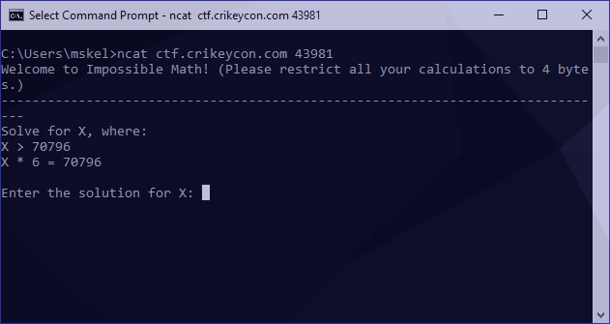

## Identifying the core problem

Since the math is impossible there’s likely a trick here. With that in mind I figure we need to overload an operator (integer overflow) and try passing a large number as input:

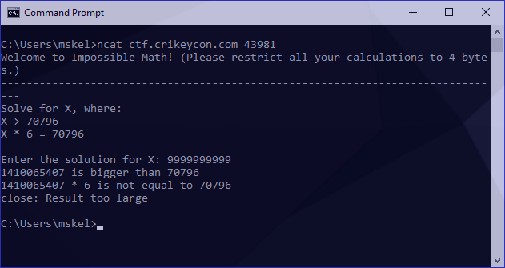

Awesome! Our integer overloads by wrapping around. To gather a bit more information I also tried an integer underflow:

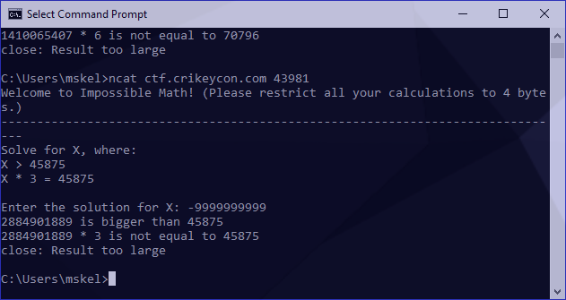

The same result. I now had to identify the figure we wrap around. These numbers are a bit irritatingly long to work with so I tried something a bit smaller to see if I could something more manageable:

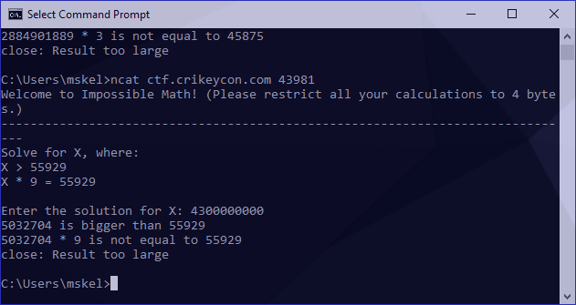

We can use the following to identify our overflow point:

is exactly 2^32, which is 1 beyond the maximum supported by unsigned int (32 bits), further supporting our case that this is an integer overflow exercise.

To validate this, I should be able to pass this value to any problem and receive 0 back as a response (as it will reach the signed amount and loop back once), as follows:

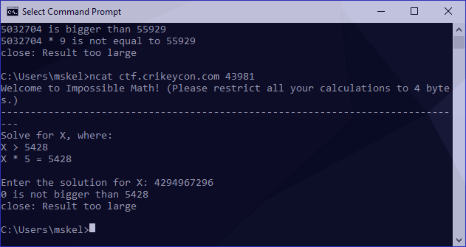

For the remainder of this exercise I’m going to refer to the variables from our second-last screenshot as the following:

Since our number wraparounds we now know we need a number with the following conditions:

* Our overflow must be lower than but higher than our to pass the first condition.
* Our overflow needs to exceed when multiplied by the and result in the

## Calculating the correct overflow

We can calculate our overflow using the following:

I turned this into a proof of concept by generating a new ncat session, which asked the following:

Solve for X, where:  
X > 37864  
X * 8 = 37864

To generate our answer, I used the following:

python -c 'print((2**32+destination)/multiplier)'

This generated the answer of as follows:

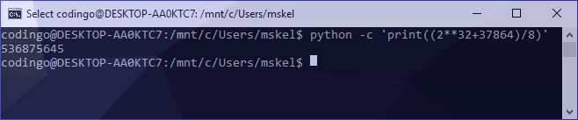

Under some circumstances, we would then be able to pipe our answer into a new ncat session but since our variables change on each connection we need to do this manually to verify it’s correct:

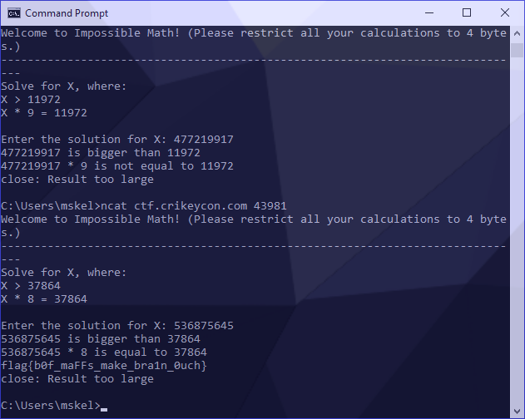

Success! Our flag was revealed.

## Creating an automatic answer tool

Manual answers are great, but this is classified as a coding challenge, not a mathematical one!

There are a few core processes to this part of the exercise. First is forming an open connection and identifying our destination and multiplier from the data that comes back. We’ve also been asked in the banner of our connection to limit our calculations to 4 bytes, so we’ll make sure we limit what we request at a time.

Splitting our variables out of the calculation is quite easy. They’re both present on the line reflected as:

We can use regular expressions to identify this packet stream from the equals sign, and then split our values out into capture groups using another expression. Putting this boilerplate together looks like the following:

#!/usr/bin/python3

import socket

import re

import operator

import sys

MAXBUF = 4096

SENTINEL = 'flag'

CTF_BOT = ('ctf.crikeycon.com', 43981)

if __name__ == '__main__':

client = socket.socket(socket.AF_INET, socket.SOCK_STREAM)

client.connect(CTF_BOT)

while True:

data = b''

# receive and store data

while True:

chunk = client.recv(MAXBUF)

data += chunk

if len(chunk) < MAXBUF:

break

# store decoded data for future usage

decoded = data.decode('utf-8')

# print out response packet

print(decoded)

# our flag contains flag{}, once it's revealed print received data and exit

if SENTINEL in decoded:

break

# skip loop until we see our X * Y = Z line

if not re.search('[=]', decoded):

continue

# select integers and store into capture groups

match = re.search('(\d+) = (\d+)', decoded)

print('multiplier: ' + match.group(1))

print('destination: ' + match.group(2))

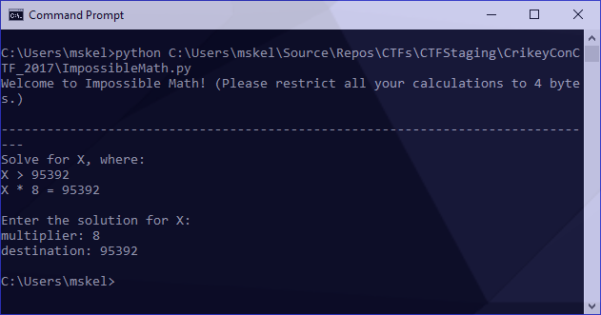

Great! We now have what we need in a variable. Referring back to our formula above, we now need to calculate:

This will look like the following (note that we cast our regular expressions back to integers to prevent operand exceptions):

multiplier = int(match.group(1))

destination = int(match.group(2))

overflow = int((2**32+destination) / multiplier)

## Final Script

Putting it all together we then have the following:

#!/usr/bin/python3

import socket

import re

import operator

import sys

MAXBUF = 4096

SENTINEL = 'flag'

CTF_BOT = ('ctf.crikeycon.com', 43981)

if __name__ == '__main__':

client = socket.socket(socket.AF_INET, socket.SOCK_STREAM)

client.connect(CTF_BOT)

while True:

data = b''

# receive and store data

while True:

chunk = client.recv(MAXBUF)

data += chunk

if len(chunk) < MAXBUF:

break

# store decoded data for future usage

decoded = data.decode('utf-8')

# print out response packet

print(decoded)

# our flag contains flag{}, once it's revealed print recevied data and exit

if SENTINEL in decoded:

break

# skip loop until we see our X * Y = Z line

if not re.search('[=]', decoded):

continue

# select integers and store into capture groups

match = re.search('(\d+) = (\d+)', decoded)

multiplier = int(match.group(1))

destination = int(match.group(2))

overflow = int((2**32+destination) / multiplier)

# encode and transfer

client.send(str(overflow).encode('utf-8')+ b'\n')

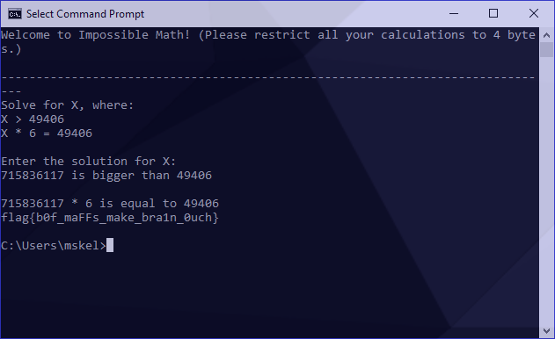

Success!